## Overview

In this activity, you will unleash your creativity and style your webpage any way you want. This is your opportunity to explore the documentation and practice the fundamentals you’ve just learned in class.

If you can read documentation, you can figure out anything. Work your Google-fu!

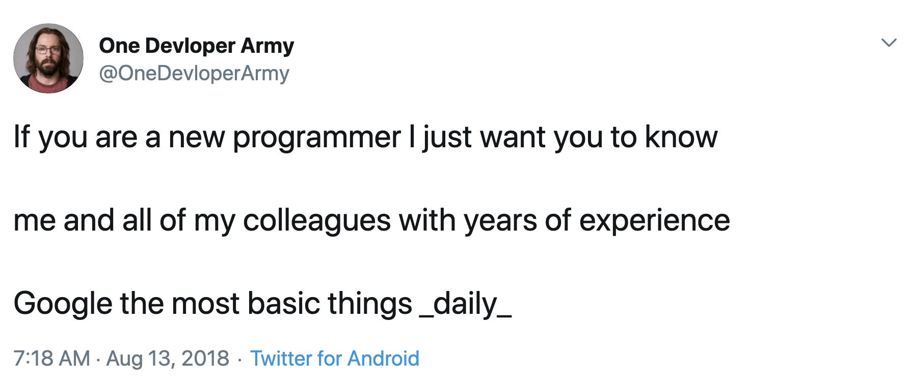

## Documentation

Refer to the documentation provided below if you have questions about certain properties and be sure to try new CSS properties:

* [CSS fonts](https://www.w3schools.com/css/css_font.asp)
* [CSS syntax overview](https://www.w3schools.com/css/css_syntax.asp)
* [CSS dimensions](https://www.w3schools.com/css/css_dimension.asp)
* File paths and images. How to link to files in folders:<https://www.w3schools.com/html/html_filepaths.asp>
* HTML img tag Documentation:<https://www.w3schools.com/tags/tag_img.asp>
* List tag documentation:<https://www.w3schools.com/html/html_lists.asp>

**Tip:** One of the most important skills to practice as a UX developer is the ability to read through the documentation. It’s a standard part of any developer’s workflow.

## Instructions

1. Open Fav_Musician.html.
   * It’s located in the Unit 17 Activities folder, inside **17.1_unsolved.zip**.
   * Remember to get in the habit of downloading the activities .zip folder each day before class.
2. Add and modify other CSS selectors and properties beyond the ones you’ve already used (font-size, color, background-color).
3. Share a screenshot of your work via Slack. Share it in the #Group_Critique channel.

## **Stretch Your Skills**

Be creative! Embrace the opportunity here to try something new. If you see a CSS property you want to try out that hasn’t been discussed or reviewed yet, go ahead!

Have fun! Remember to remain curious—the journey to learning any programming language is full of experimentation and happy accidents.

**In the Real World**

HTML + CSS has a lot of experimentation. Start small and build up to more complex visual designs in code. Try reverse engineering as visual design and use Chrome inspect development tools to understand how elements are styled in CSS.